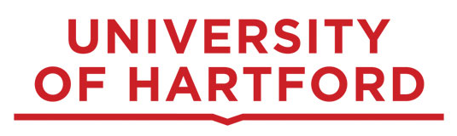

Doctoral Dissertation Defense
Educational Leadership for Social Justice
College of Education, Nursing and Health Professions

A Mixed-Methods Evaluation of the Relationship Between Student Self-efficacy and Radiography Certification Exam Success

Research Study
This mixed-methods study examined radiography program directors’ perceptions of factors that may contribute to declining first-time pass rates on the American Registry of Radiologic Technologists (ARRT) radiography certification examination. Guided by Bandura’s self-efficacy theory, the study explored relationships among increasing automation of radiographic equipment, opportunities for students to apply knowledge in the clinical environment, student self-efficacy, and readiness for the certification examination. The study also identified curricular and clinical barriers to student success and pedagogical approaches that radiography program directors believe may help students overcome these challenges.

About the Researcher
Daniel DeMaio, M.Ed., R.T.(R)(CT)(ARRT), is a doctoral candidate in the Educational Leadership for Social Justice program at the University of Hartford. Daniel currently serves as the Director of Professional Resources and Relations for the American Society of Radiologic Technologists (ASRT) in Albuquerque, NM and as an adjunct instructor for the University of Hartford Radiologic Technology Program.

Join the Presentation:
Friday, September 4, 2026, from 1:00 pm – 2:00 pm on Microsoft Teams

